2001 Series Ultrasonic Knife

ULTRASONIC SUMMARY

The ultrasonic cutting method is extremely useful with certain, difficult to cut, materials such as pre-preg kevlar where traditional cutting methods fail. It is a process that has benefited companies involved with composite processing, food processing, boat building, the aerospace industry and many more.

The operation of this system is the same as that of Spectrum’s other cutting systems. It features user friendly front-end software that makes production an extremely simple task. Utilizing on screen overlays and allowing varied setup configurations relating to different cut jobs or materials to be stored, the software saves time and effort which can be better spent elsewhere. Upon commencement of a cut, the software commands the motion system to move to the start position, initialize the ultrasonic titanium horn, lower the blade into the material and then tangentially steer the blade to follow the programmed cut path accurately to within 0.25mm. No further interaction is then required from the user as the cut is completed.

During operation, the ultrasonic blade vibrates thousands of times every second. This vibration action causes the tool to glide though the material, with the vibration itself parting the material almost at a molecular level, causing a cutting action in addition to the cut edge guided by the motion system. This also has the benefit of preventing materials with a difficult “sticky” structure from attaching to the blade, which would seriously hamper cutting progress and possibly even causing the damage to the material being cut and blade breakage.

2001 SERIES DATA

Ultrasonic advantages:

- Good for cutting sticky/tricky materials (resins & glues don’t stick to blade)

- Can seal edge if set up correctly

- Cold cutting method (No heat based damage to materials)

- No fume extraction etc required

- Good cut speeds – Around 300 mm per second possible

Ultrasonic disadvantages:

- Contact required during cutting (Could cause problems with some materials)

- 4 axes required (Forwards, backwards + left, right +up, down + rotational)

- Blades need regular replacement

ULTRASONIC PICTURES

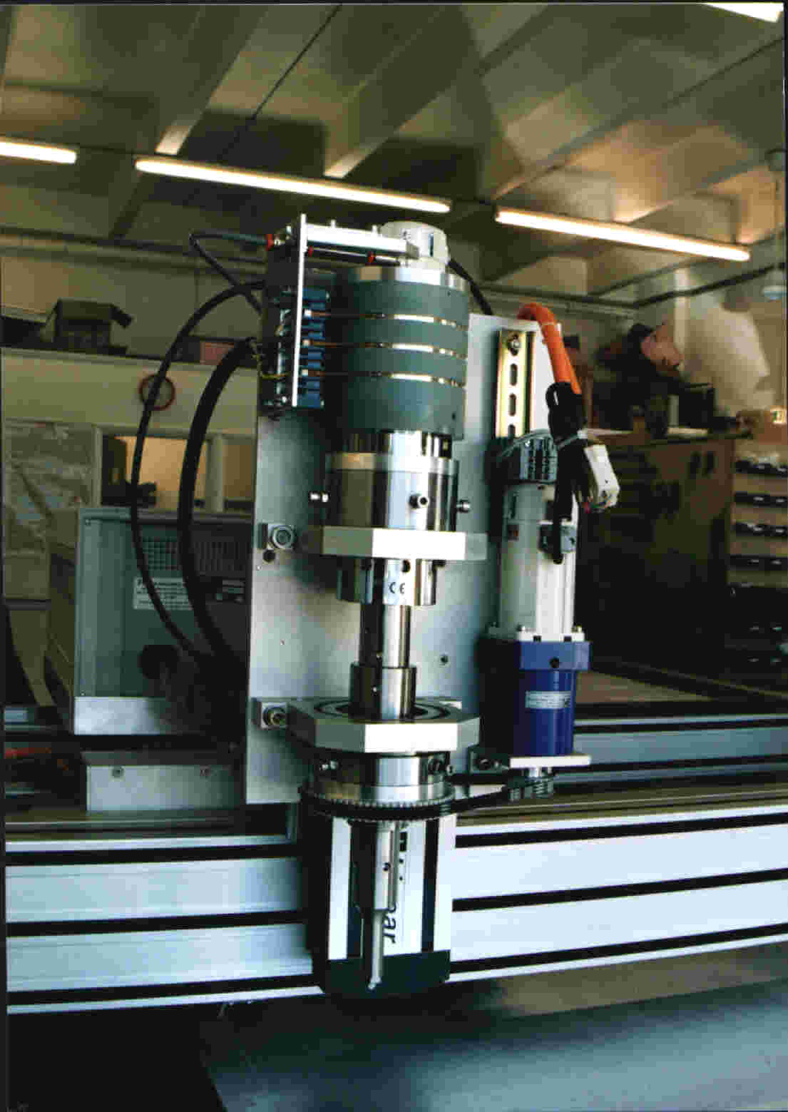

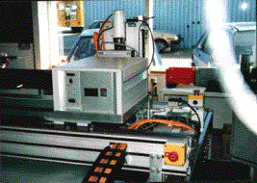
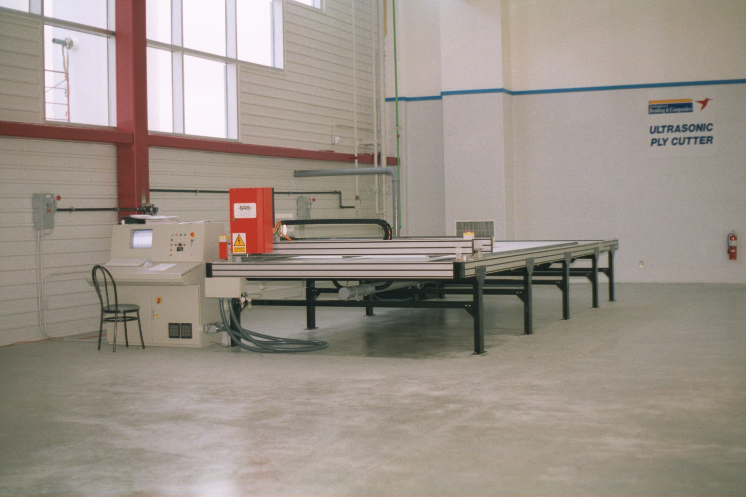

Ultrasonic tool head Ultrasonic generator 6m x 2m Ultrasonic system installed

