2000 Series Laser Knife

LASER SUMMARY

Laser cutting is a very versatile cutting method with very accurate power control and high cut speeds possible. It is used in many industries in the manufacture of such products as sails, balloons, airships, tents, clothing, a wide range fabrics, and many more.

The 2000 Series Laser Knife is currently the most popular of Spectrum’s cutting systems, mainly due to its many advantages and wide-ranging customer base.

The operation of this system is the same as that of Spectrum’s other cutting systems. It features user friendly front-end software that makes production an extremely simple task. Utilizing on screen overlays and allowing varied setup configurations, relating to different cut jobs or materials, to be stored – the software saves time and effort which can be better spent elsewhere. Upon commencement of a cut, the software commands the motion system to move to the start position, open the laser shutter and then follow the programmed cut path accurately to within 0.25mm. At the same time, the laser controller is monitoring the speed of the motion and adjusting the power of the laser accordingly. Therefore, the process requires no user interaction from the moment of initialization.

Spectrum utilize different types and manufacturers of laser, depending upon the application and location of the system. Laser units range from 25 watt to 3000 watt The power can then be set anywhere up to the laser’s maximum capability.

Different laser types work on different principles but ultimately in a similar lasing fashion. With an electricaly excited laser, an electrical voltage is passed between electrodes in a sealed tube filled with gas. The laser gas is excited, creating light of a certain wavelength. This light is called a photon. As the photons travel faster and faster within the tube, a few photons are allowed a controlled escape and are focussed and directed onto the material to be cut. With an RF excited laser, high frequency is used to excite the lasing gas with the same result as above.

2000 SERIES DATA

Laser advantages:

- Seals edges on some materials (Possibly a disadvantage in rare cases)
- Fast cut speeds – 1 meter per second + possible
- Non contact cutting method
- Focus adjustment – variable kerf width (cut path width) – 1mm holes possible
- Only 2 axes required (Forwards, backwards + left, right)
- Extremely versatile (Both potential cut materials and settings)

Laser disadvantages:

- Can burn edges of some materials (Though can be avoided by modifying settings)
- Requires fume extraction
- Heat could be unsuitable with some materials

Sample cut speeds of various textiles provided by manufacturer:

MATERIAL LASER PWR THICKNESS CUT SPEED
Acrylic 100 W 6.35mm 240mm/min
Dacron 150 W 0.95mm 2870mm/min
Macro-tent material 115 W 0.38 – 1mm 12,180mm/min
Nylon/polyester 160 W 1mm 8382mm/min

LASER PICTURES
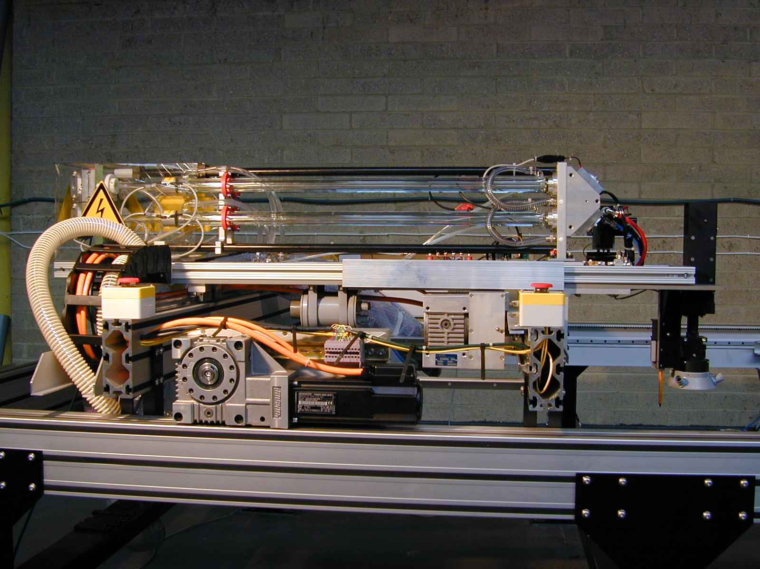
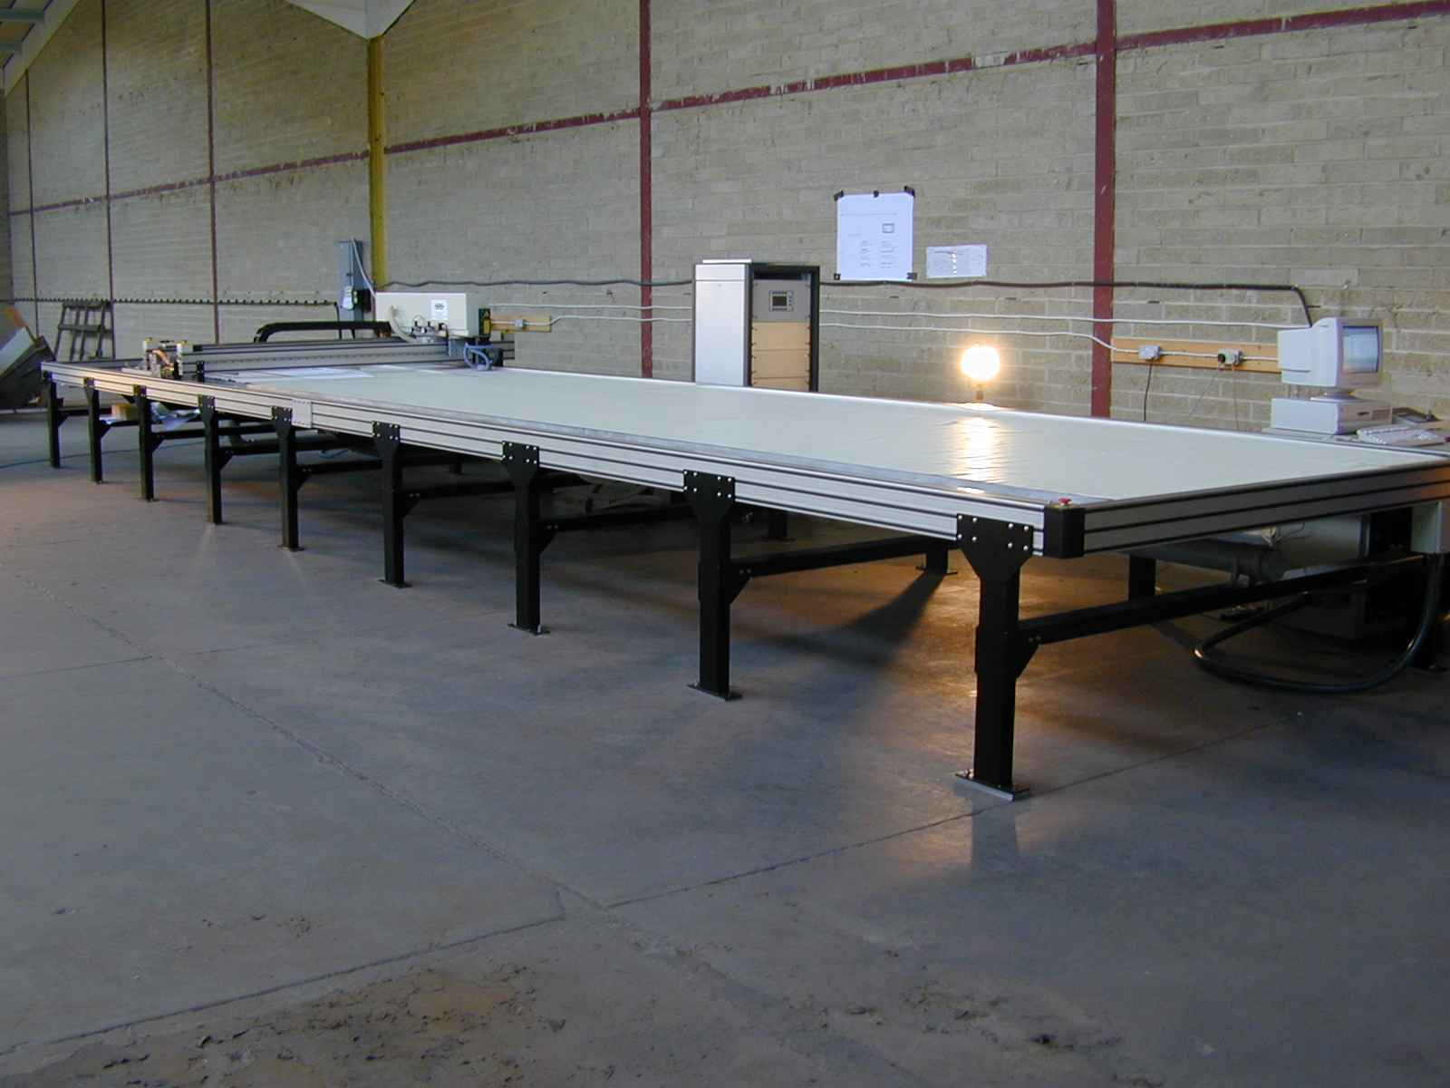

200 watt CO2 Laser (without safety cover) Completed system, ready to ship
(200 watt CO2 Laser – 10m x 2m cut area)

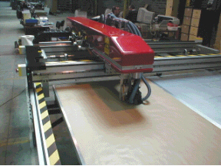
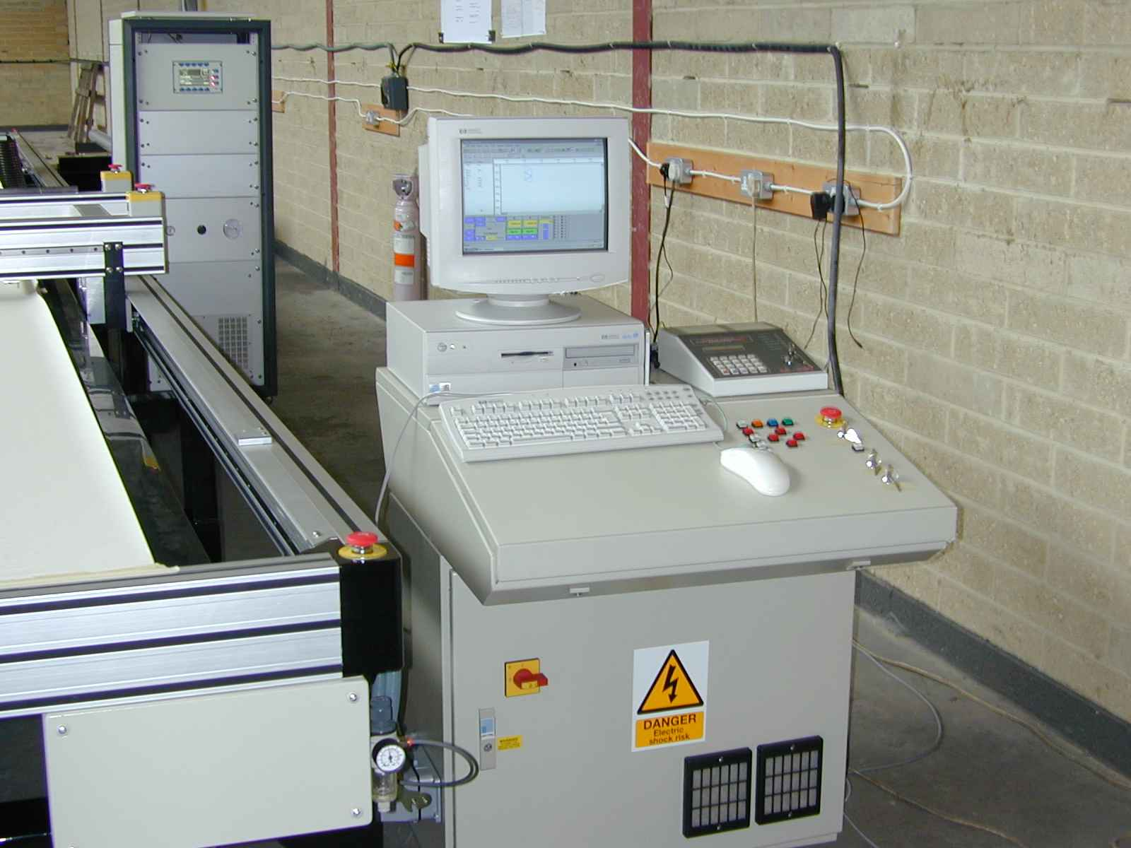

Operator control console 200 watt CO2 Laser mounted on cross axis

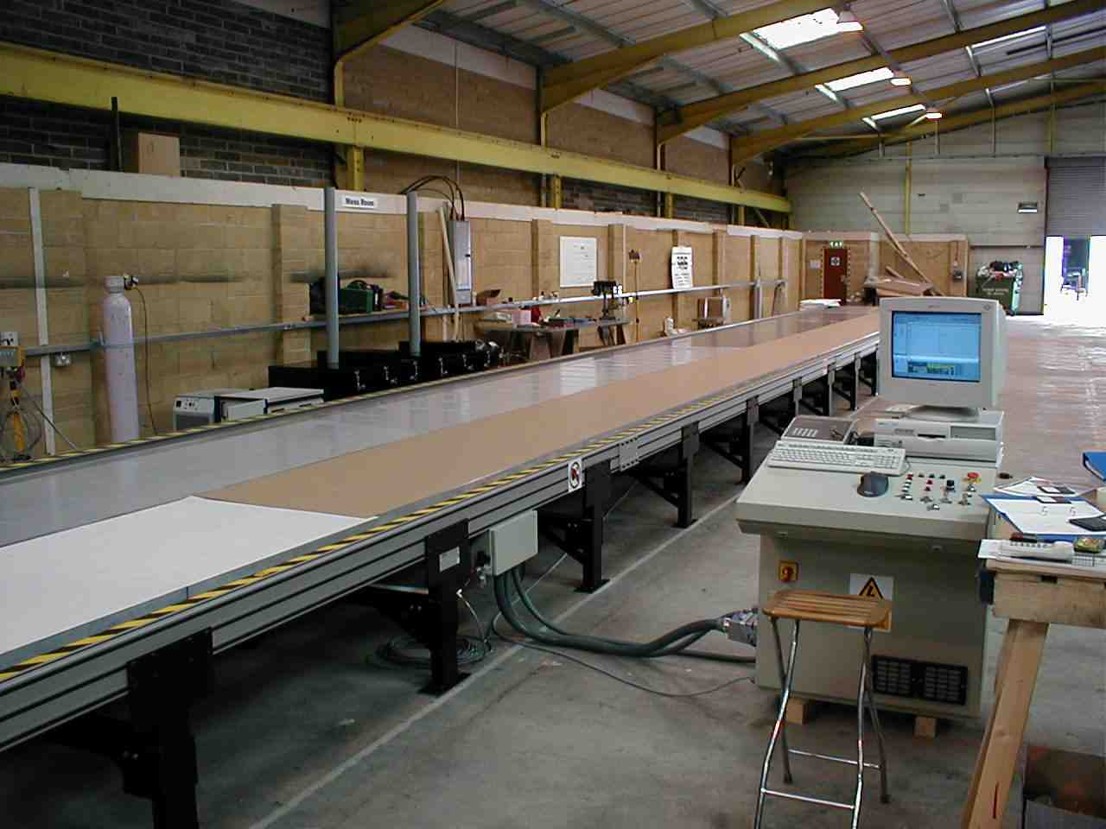
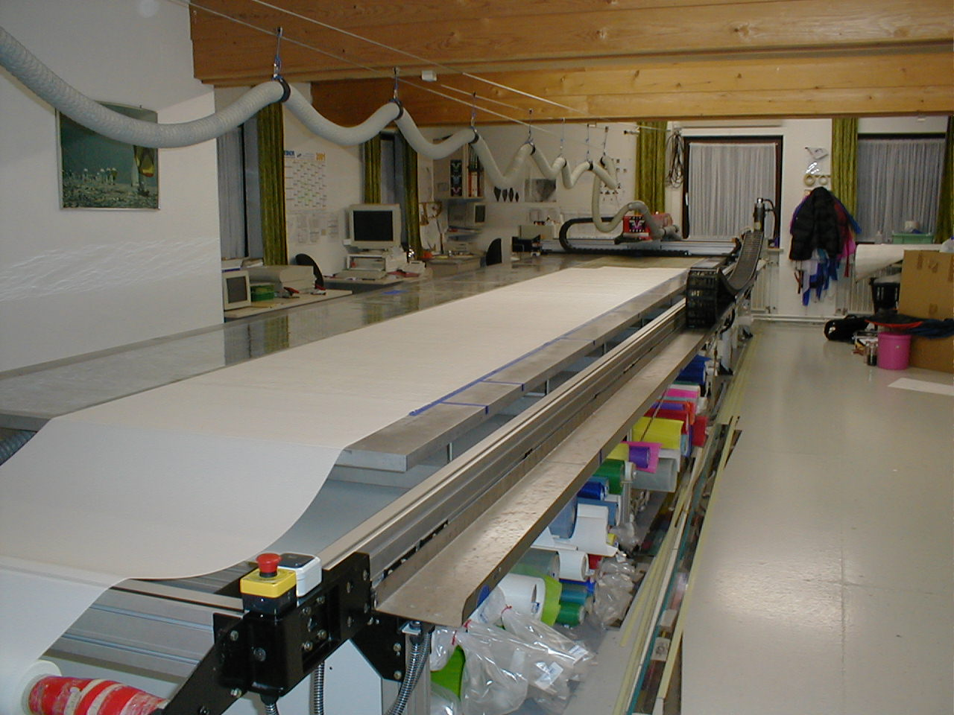

Completed 26m x 2m Laser system A system installed and in operation

